Academic year 2025-2026

20CYS401
Secure Software Engineering

Lab Record

Submitted by
Kiruthik Pranav P V
CH.EN.U4CYS22026

Amrita Vishwa Vidyapeetham Chennai – 601 103, Tamil Nadu, India.
October 2025

Step 1 — Mini SRS: AI Chatbot API Wrapper
Project name: AI Chatbot API Wrapper
Stakeholders: Developer team, Security lead, DevOps engineer, End users (clients/apps), Product owner

1. Purpose
Provide a secure, lightweight REST API wrapper around the OpenAI Chat API that applications can call to send user prompts and receive model responses. The wrapper centralizes usage, enforces rate limits, abstracts model details, and — critically — protects the OpenAI API key(s) and any client tokens from leakage.

2. Scope
- Expose endpoints for: /v1/chat (send prompt & get response), /v1/conversations (list/persist conversations), basic CRUD on saved prompts, and admin endpoints to rotate keys.
- Authentication for clients (API tokens or OAuth2 bearer tokens).
- Server-side secure storage of OpenAI API key(s).
- Logging, metrics, and basic rate-limiting.
- Deployment using Docker and Kubernetes (minikube for lab).
- Focus: ensure secrets (OpenAI API key, client tokens) are never exposed in logs, responses, or container images.

3. Functional Requirements (FR)
FR1 — Chat endpoint: POST /v1/chat accepts {client_id, conversation_id, message} and returns AI reply.
FR2 — Authentication: All client API calls must present a bearer token. Unauthorized requests return 401.
FR3 — Conversation CRUD: Create/read/update/delete conversation metadata (no sensitive storage of raw API keys).
FR4 — Admin key management: Admin can rotate OpenAI API key via protected admin endpoint or via Kubernetes Secrets.
FR5 — Rate limiting: Per-client rate limiting configurable (default 60 requests/min).
FR6 — Audit logging: Log request metadata (client_id, endpoint) but never log Authorization header, full prompt content if flagged private, or the OpenAI API key.
FR7 — Health & metrics: /health and /metrics endpoints for k8s health checks and Prometheus scraping.

4. Non-Functional Requirements (NFR)
NFR1 — Security: Secrets must be stored encrypted at rest (e.g., via K8s Secrets + encryption) and in-memory for minimal time. No API keys in source repo or image.
NFR2 — Availability: 99.9% uptime target for production. App should gracefully handle transient OpenAI API failures with exponential backoff.
NFR3 — Performance: Typical response latency < 1.5s (excluding OpenAI model latency) under normal load.
NFR4 — Scalability: App must run horizontally in Kubernetes.
NFR5 — Observability: Structured logs (JSON), traces, and metrics must be emitted.
NFR6 — Maintainability: Codebase modular (routes, auth, key-manager, services).

5. Constraints
- Must use Flask (Python) for the wrapper.
- OpenAI API key use is limited by the plan; rate-limiting must protect the shared key.
- In lab: use minikube/local Kubernetes; prefer secrets mounted via k8s Secret.
- Local dev may use a .env file but production images must not contain secrets.
- No third-party secret manager configured in the lab beyond Kubernetes Secrets (optional placeholder for HashiCorp Vault).

6. Acceptance Criteria (concrete, testable)
AC1 — Unauthenticated request to /v1/chat returns 401 Unauthorized.
AC2 — Authenticated request with valid client token returns a 200 with {"reply": "..."}; the OpenAI API key is never present in logs or response body.
AC3 — When admin rotates the OpenAI key (via the admin endpoint or by updating the Kubernetes Secret), subsequent chat calls use the new key without requiring container rebuild.
AC4 — Container image build logs and image contents do not include the OpenAI API key (verified by scanning image layers).
AC5 — Rate limiting rejects excessive requests with 429 and logs the event (without logging tokens).
AC6 — Health endpoint returns 200 when app is functional and 503 when critical dependency (e.g., keys missing) is absent.

7. Minimal Data Model / Storage
- clients collection/table: {client_id, hashed_token, rate_limit_config, scopes, created_at}
- conversations collection/table: {conversation_id, client_id, summary, created_at, updated_at}
- Secrets store: OpenAI API key stored only in Kubernetes Secret or environment variable passed at runtime and never checked into repo.

8. Security Considerations (quick list)
- Use HTTPS/TLS for all client-app traffic.
- Store client tokens hashed (e.g., HMAC or bcrypt) and validate via secure comparison.
- Rotate OpenAI key regularly; support hot rotation.
- Redact and avoid storing PII in logs.
- Use minimal privileges for Kubernetes service accounts.
- Use CSP/HTTP security headers where relevant.

Step 2 — Agile Planning

🎯 User Stories (Security-Focused)
User Story 1 — Core Chat Functionality
As an authenticated client application,
I want to send a prompt to the chatbot API wrapper
so that I can receive AI-generated responses securely without exposing my OpenAI key.
Acceptance Criteria:
- If I provide a valid Bearer token → I should get a 200 response with { "reply": "<AI message>" }
- If I provide an invalid or missing token → I should get 401 Unauthorized
- OpenAI key must NOT be visible in response or logs.

User Story 2 — API Key Security & Rotation
As an admin/security engineer,
I want to rotate the OpenAI API key without redeploying the entire application
so that I can maintain secret hygiene without downtime.
Acceptance Criteria:
- Updating the Kubernetes Secret or calling /admin/rotate-key reloads the key in runtime.
- Existing chat sessions continue working using the new key.
- No key exposure in logs or responses.

🏃 Sprint Plan (Single Sprint — 1 Week Example)
Task | Description | Story | Owner | Status
T1 | Setup Flask skeleton with /v1/chat endpoint | US1 | Dev | Planned
T2 | Implement bearer token authentication | US1 | Dev | Planned
T3 | Securely inject OpenAI API key via environment variable | US1 | DevOps | Planned
T4 | Implement /admin/rotate-key handler & hot reload | US2 | Dev | Planned
T5 | Write unit tests for auth + key rotation | US1/US2 | QA | Planned
T6 | Dockerize the app | US1 | DevOps | Planned
T7 | Deploy to Minikube with Kubernetes Secrets | US2 | DevOps | Planned
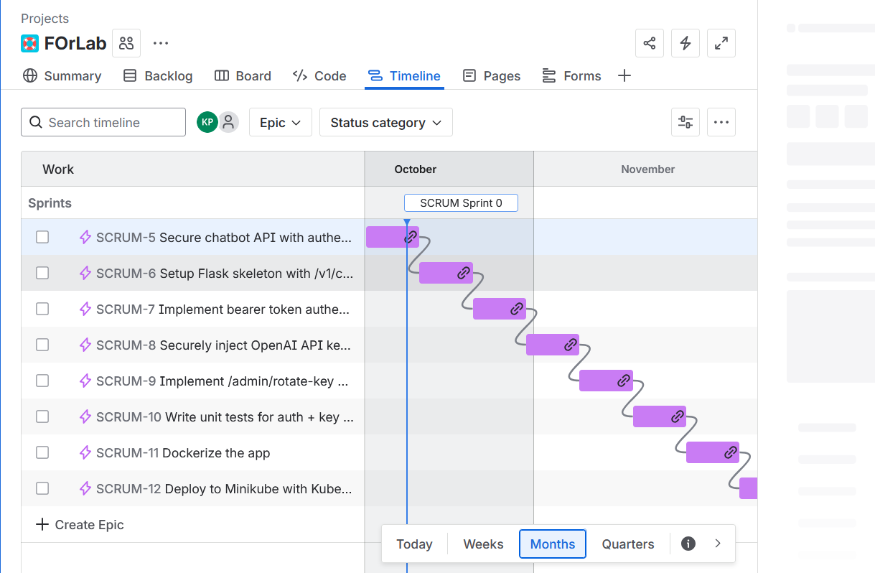

Step 3 — Design

Level 0 DFD Description
Entity / Component | Type | Interaction | Data Flow Description
User / Client App | External Entity | ➝ Sends request | Sends prompt + Bearer token via /v1/chat
Flask API Wrapper | Process | ⇆ Handles logic | Validates token → forwards to OpenAI API → returns response
Authentication Module | Sub-process | ✅ Validates client token | Compares hashed token against stored credentials
OpenAI API | External System | ↔ External request | Flask wrapper sends prompt using secured API key
Database (Conversations & Clients) | Data Store | ⬅️ Store / Fetch | Saves conversation metadata and hashed tokens
Admin / Security Engineer | External Entity | 🔄 Key Rotation | Updates OpenAI key via /admin/rotate-key or Kubernetes Secret

DFD – Bullet Format (Suitable for Visual Conversion)
- External Entity: User / Client App
→ Sends prompt + bearer_token → Process: Flask API Wrapper
- Process: Flask API Wrapper
→ Calls Authentication Module to validate token
→ If valid → forwards prompt to OpenAI API
→ Receives AI response → Returns response to User
- Data Store: Database
→ Fetch client credentials for auth
→ Store conversation metadata
- External Entity: Admin / Security Engineer
→ Calls /admin/rotate-key → Updates OpenAI API Key in Key Store / Secret Manager (K8s Secret)
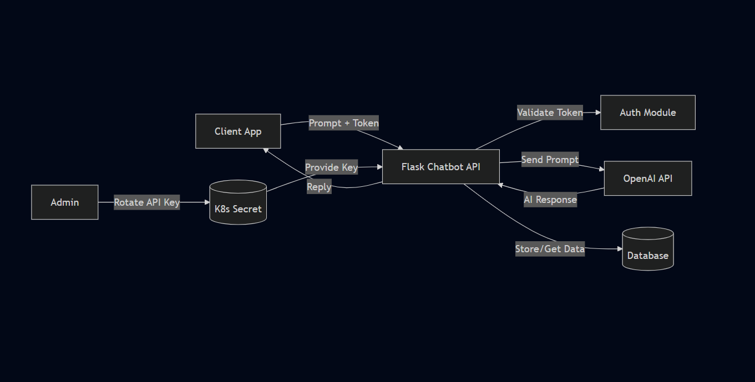

Step 4 — Threat Analysis

We’ll identify 2 key threats using STRIDE, then draw an attack tree for one of them.

🎯 STRIDE Threats (Specific to API Token Security + Flask Wrapper)
STRIDE Category | Threat | Description | Impact
S – Spoofing | Client impersonation via stolen API token | An attacker steals or guesses a client’s Bearer token and makes unauthorized requests. | Unauthorized access, quota abuse.
T – Tampering | Modification of OpenAI API response in transit | MITM attack injects or alters chatbot responses before reaching the user (if HTTPS is misconfigured). | Misleading or manipulated AI replies.
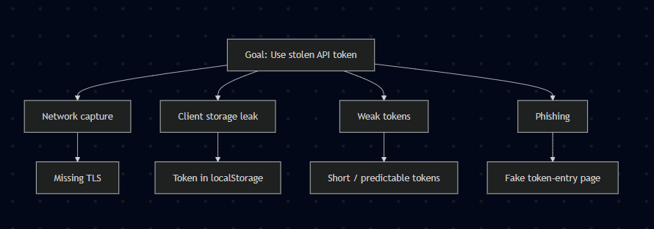

Explanation (for each node)
Goal: Use stolen API token
An attacker’s objective is to obtain a valid client bearer token and call the chatbot API as that client, gaining unauthorized access and possibly abusing quotas or data.
Network capture (Missing TLS)
If traffic between the client and API is not fully encrypted (no HTTPS, mixed content, or weak TLS), an attacker on the same network or in-path can sniff or tamper with requests and extract bearer tokens.
Client storage leak (Token in localStorage)
When client apps store tokens in insecure places (e.g., browser localStorage, plain config files, or unprotected device storage), a local attacker or malicious script can read and exfiltrate the token.
Weak tokens (Short / predictable tokens)
Tokens with low entropy, predictable patterns, or long lifetimes can be guessed or brute-forced—especially when authentication endpoints lack rate-limiting—allowing attackers to discover valid tokens.
Phishing (Fake token-entry page)
Users or admins can be tricked into pasting their token into a malicious page or form, or into entering credentials that reveal tokens, which the attacker then reuses against the API.

Mitigations (mapped to nodes and prioritized)

Immediate (high priority)
- Enforce TLS + HSTS (mitigates Network capture)
  - Require HTTPS on all endpoints, redirect HTTP → HTTPS, enable HSTS, and disable old TLS versions.
  - Use strong cipher suites and regularly scan for TLS misconfigurations.
- Avoid localStorage; use secure storage + short-lived tokens (mitigates Client storage leak)
  - For web clients, prefer httpOnly, secure cookies with sameSite where applicable, or a backend session proxy.
  - For native apps, use platform secure storage (iOS Keychain / Android Keystore).
  - Design tokens to be short-lived (minutes) and use refresh tokens held in secure storage.
- Use strong, high-entropy tokens + scopes (mitigates Weak tokens)
  - Generate tokens with sufficient entropy (≥128 bits) or use signed JWTs with short expiry and minimal scopes.
  - Avoid predictable token formats.
- Rate-limit & anomaly detection (mitigates Weak tokens & general abuse)
  - Apply per-client throttling, exponential backoff on auth failures, and detect unusual usage patterns (sudden spike, geo-drift).
  - Block or temporarily suspend suspicious clients automatically.

Step 5 Test Case Generation

Test Case ID | Type | Description | Steps | Expected Result
TC1 | Functional | Test sending a valid chat prompt | 1. Send POST request to /v1/chat with valid token and prompt. 2. Observe response. | HTTP 200 OK; JSON contains non-empty reply; no secrets returned; conversation metadata stored.
TC2 | Security | Test access with invalid/revoked token | 1. Send POST request to /v1/chat with invalid/revoked token. 2. Observe response and logs. | HTTP 401 Unauthorized; error message returned; no secrets leaked in response or logs.
TC3 | Negative | Test sending malformed JSON payload | 1. Send POST request to /v1/chat with malformed JSON body. 2. Observe response. | HTTP 400 Bad Request (or 422); error message returned; server remains healthy; input not forwarded to OpenAI.

Step 6 Containerization

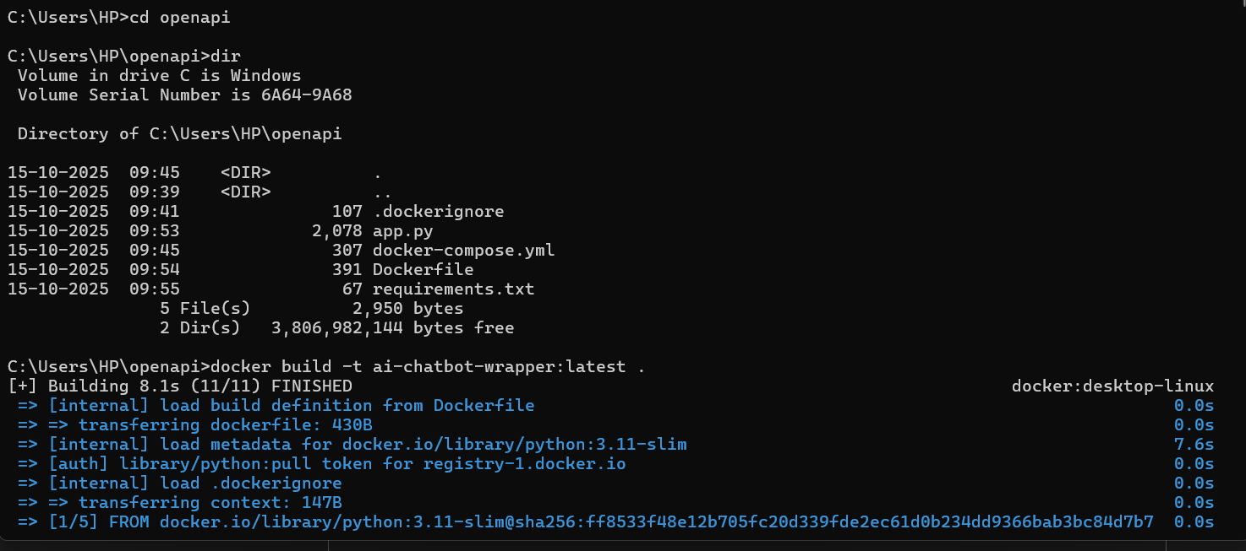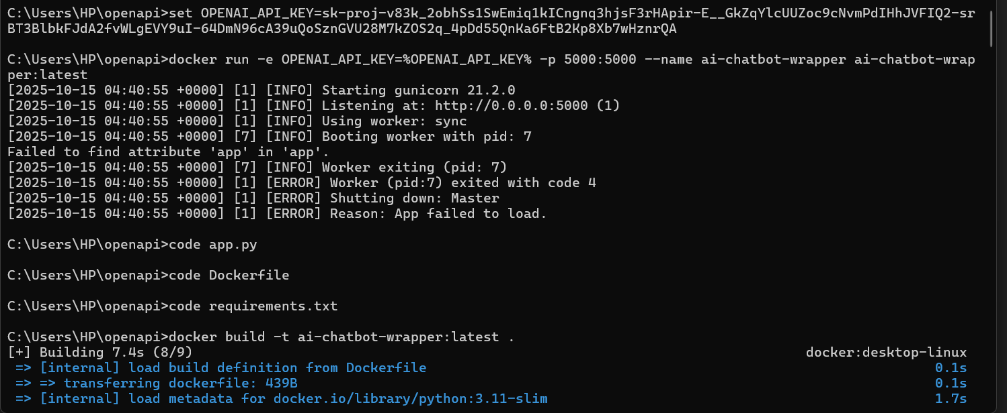

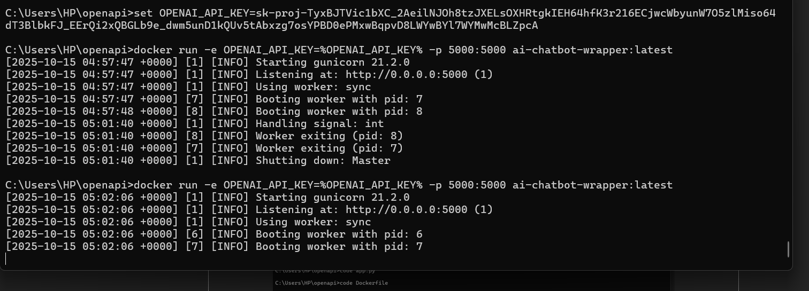

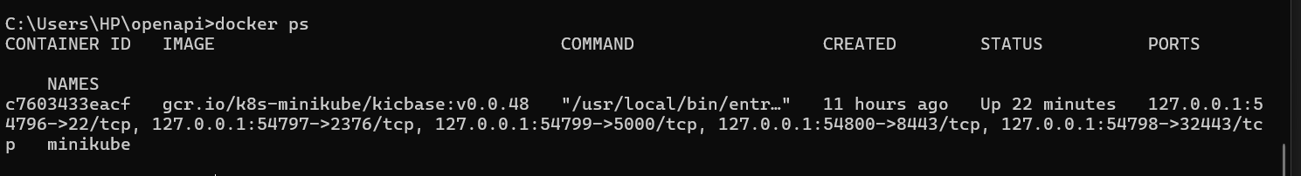

Step 7 Kubernetes Deployment

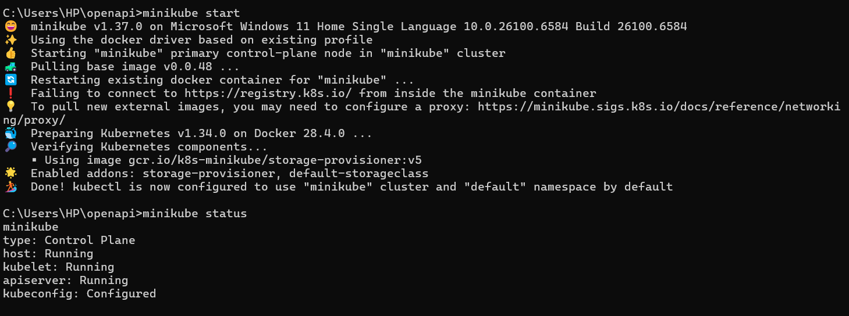

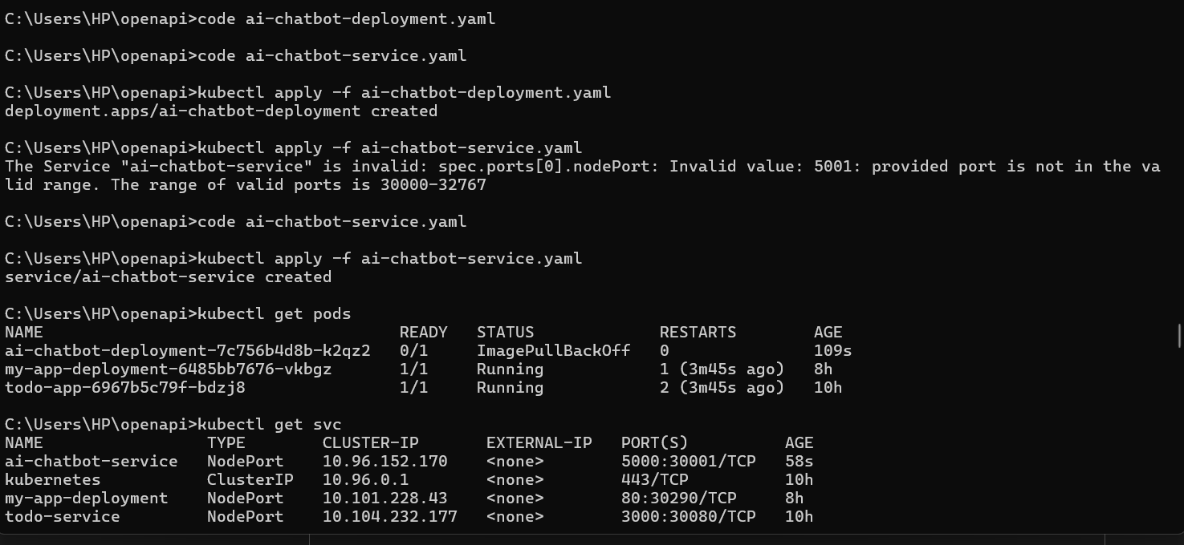

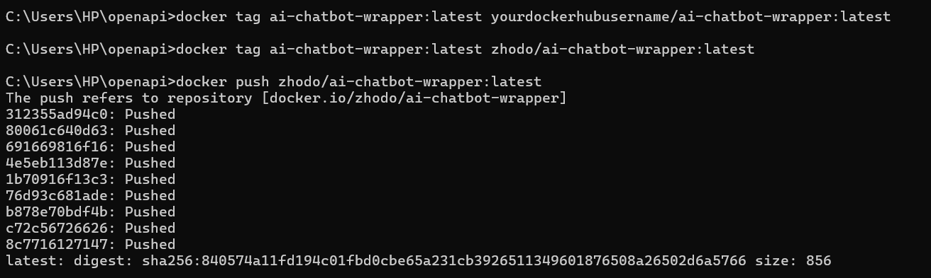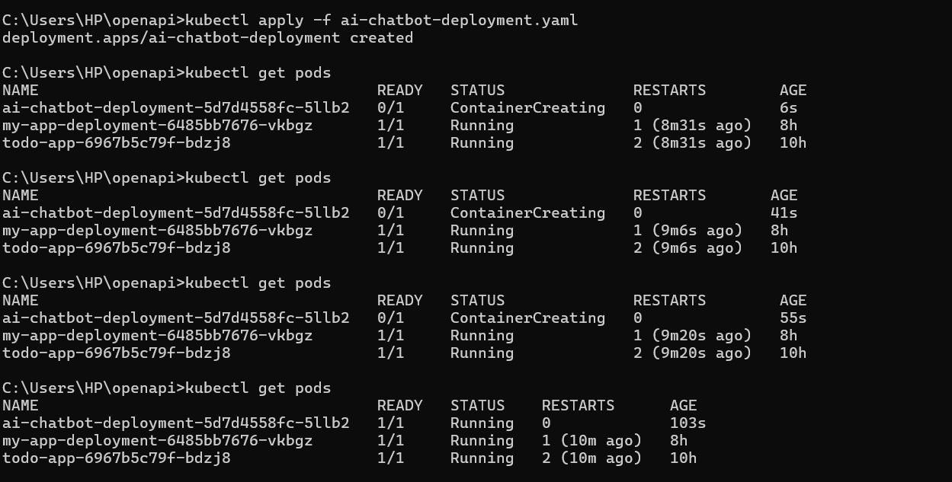

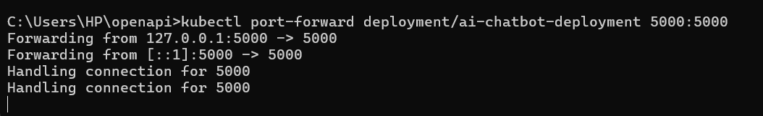

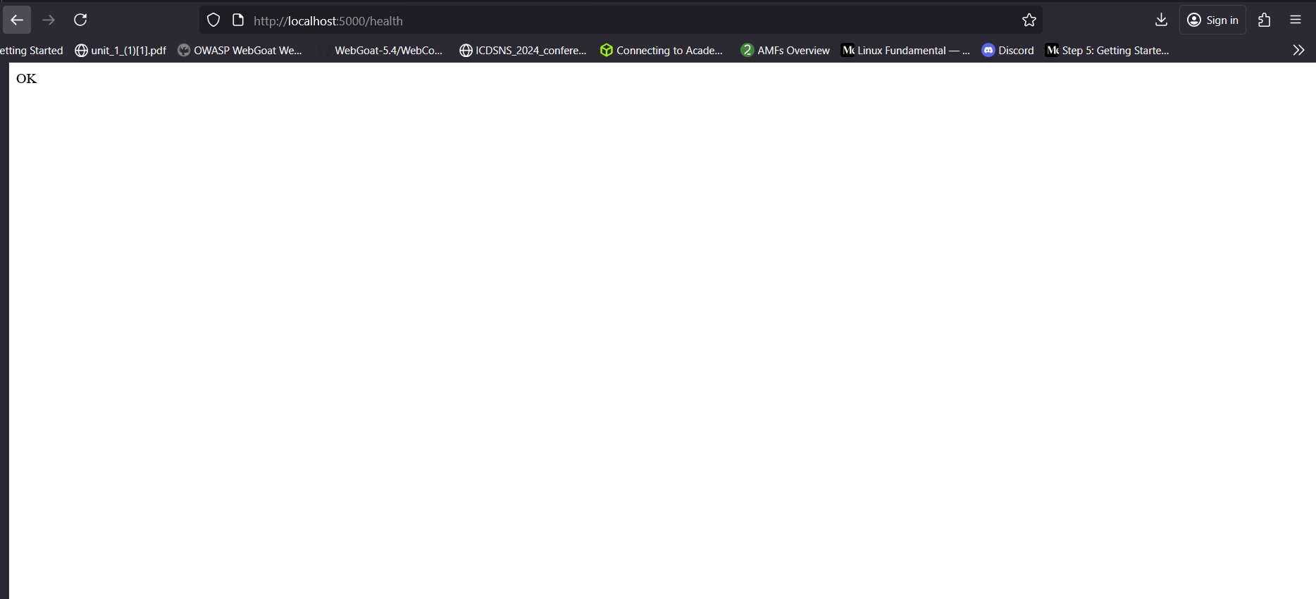

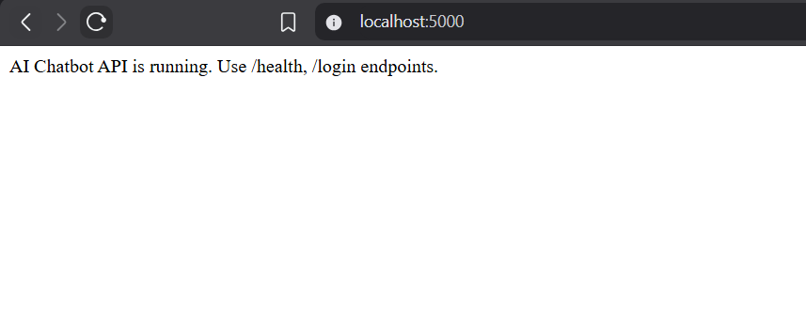

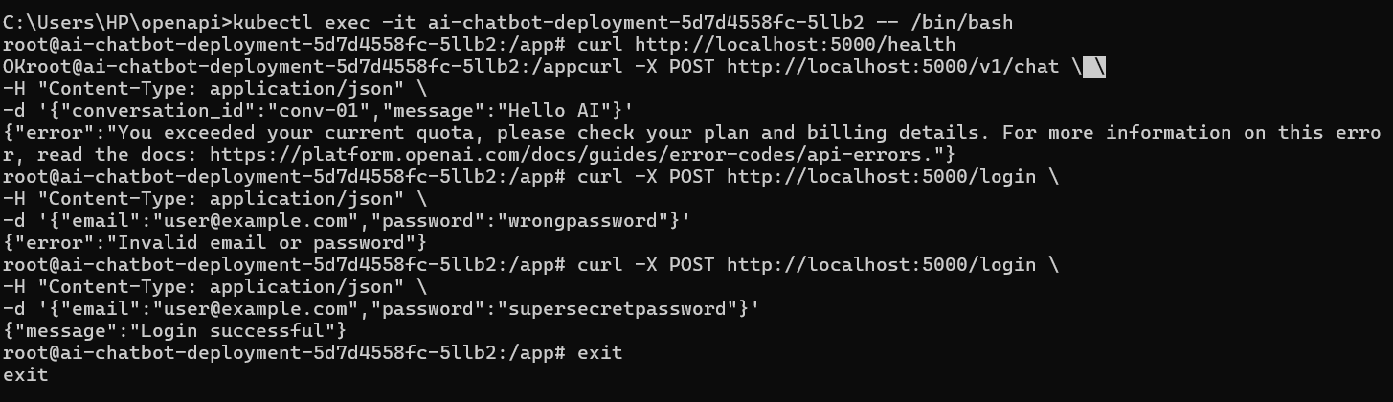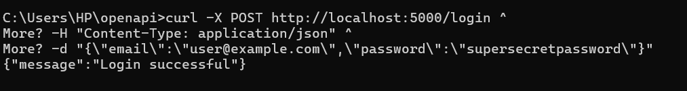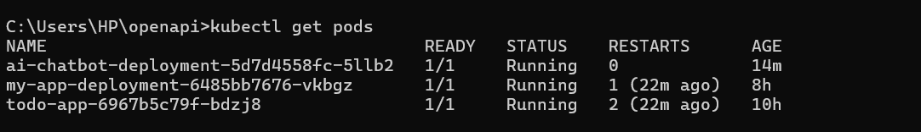

Step 8: Security Improvement – API Token Protection

Focus Area: API Token Security

Problem Identification
In the initial implementation, the Flask application directly used the OpenAI API key from the environment variable. However, the /v1/chat endpoint was publicly accessible without authentication. This meant that anyone who could reach the endpoint could make requests and exhaust the OpenAI API quota, potentially leading to unauthorized usage and billing risks.

Security Improvement
To enhance security, an additional server-side API token was introduced. Every request to the /v1/chat endpoint must now include this token in the request headers. Only requests with the correct token are allowed to interact with the API.

Implementation Details

Before Security Improvement
# app.py
OPENAI_API_KEY = os.getenv("OPENAI_API_KEY")
openai.api_key = OPENAI_API_KEY

@app.route("/v1/chat", methods=["POST"])
def chat():
data = request.get_json()
user_message = data["message"]
response = openai.ChatCompletion.create(
model="gpt-3.5-turbo",
messages=[{"role": "user", "content": user_message}]
)
ai_reply = response.choices[0].message.content.strip()
return jsonify({"reply": ai_reply})

Issue: Anyone could access /v1/chat and use the OpenAI API key.

After Security Improvement
# app.py
API_TOKEN = os.getenv("CHATBOT_API_TOKEN")

def verify_api_token(request):
token = request.headers.get("X-API-KEY")
return token == API_TOKEN

@app.route("/v1/chat", methods=["POST"])
def chat():
if not verify_api_token(request):
return jsonify({"error": "Unauthorized"}), 401

data = request.get_json()
user_message = data["message"]
response = openai.ChatCompletion.create(
model="gpt-3.5-turbo",
messages=[{"role": "user", "content": user_message}]
)
ai_reply = response.choices[0].message.content.strip()
return jsonify({"reply": ai_reply})

Usage Example
curl -X POST http://localhost:5000/v1/chat \
-H "Content-Type: application/json" \
-H "X-API-KEY: mysecret123" \
-d '{"conversation_id":"conv-01","message":"Hello AI"}'

Benefits
- The OpenAI API key is never exposed in client requests.
- Only authorized requests with the correct API token can access the chatbot endpoint.
- Prevents unauthorized quota consumption and enhances overall API security.
- Easily scalable – additional API tokens can be implemented per user/service in the future.

Step 9: Final Output:

